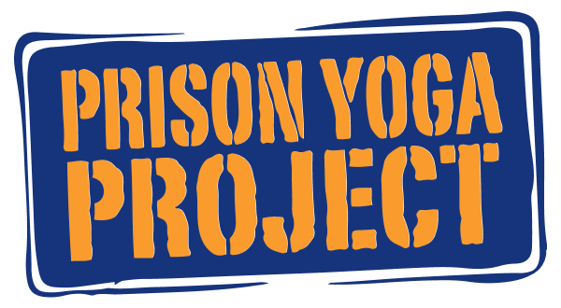

Facilitator Application Template

Use this Facilitator Application Template to prepare your responses ahead of time. When you are ready, please visit prisonyoga.org/facilitator-application to start your application.

Training, Education, & Work Experience

Yoga Teacher/Therapist Training
Please list 200/300/500-Hour Yoga Teacher Training and IAYT Accredited Yoga Therapy programs you have completed. Include the type of training, school/studio, and date completed, listed one per line.

Have you attended training with Prison Yoga Project?
- Yes
- No

Prison Yoga Project Training
Please list the training that you have completed with Prison Yoga Project, including the approximate date and location, listed one per line.

Additional Yoga Training/Workshop(s)
Please list other relevant yoga training and workshops you have completed. Include the type of training, school/studio, and date completed, listed one per line.

Other Education and Credentials
Please list other post-secondary education or other credentials completed. Include the name of the degree, institution, and date completed.

Certifications
- C-IAYT
- RYT 200
- RYT 500
- SEP
- MSW
- MFT
- Other

Work Experience
You can either upload a resume or enter your work experience as text; please prepare for the online application ahead of time.

Availability

How often would you be able to dedicate half a day to this work?
- Daily
- More than once per week
- Weekly
- Twice/month
- Monthly
- Occasionally

Best times of the day?
Select all that apply:
- Morning
- Afternoon
- Evening

Best days of the week?
Select all that apply:
- Sunday
- Monday
- Tuesday
- Wednesday
- Thursday
- Friday
- Saturday

How stable is your current situation?
Are there any considerations that might impact or inhibit your ability to make a long-term and consistent commitment, approximately one year? Are your plans and circumstances (e.g. travel, employment, residence) predictable?

Population(s) of Interest:
- Youth
- Men’s Facility
- Women’s Facility

Opportunity

Are you currently facilitating a program or in contact with or have a connection to a facility where there is an opportunity to start a new program?
- Yes
- No

Please describe the opportunity:

Let's Get to Know You

What led you to take the PYP training? Why are you passionate about becoming a PYP Facilitator and serving those incarcerated?

What (if any) concerns do you have about facilitating inside?

In your opinion, what do you consider to be the most vital component of trauma-informed practice? Why?

Describe your yoga and mindfulness practice. What do you believe is the main benefit of maintaining a consistent practice?

What experience do you have teaching yoga to diverse populations? If this would be your first experience, how will you ensure that you are adapting your class to meet the needs of your participants?

What resources - books, podcasts, websites, etcetera - have you found to be most useful in learning more about trauma, the criminal justice system, yoga, and so on?

What would you do if…

Unexpected situations often arise when facilitating yoga on this inside. Listed below are several examples of situations you may experience.

...a participant comes into the practice, lies down on the mat, crosses their arms, and does not participate?

...during a balancing pose, a student begins to mimic Karate Kid moves?

...you have chosen to introduce a crow pose in a class and notice that a participant(s) have become competitive, frustrated, overwhelmed, or are making unsafe choices?

...a regular participant is behaving uncharacteristically?

…custody staff enters the room and advises you to end your practice early?

Anything Else?

Is there anything else you would like us to know?

